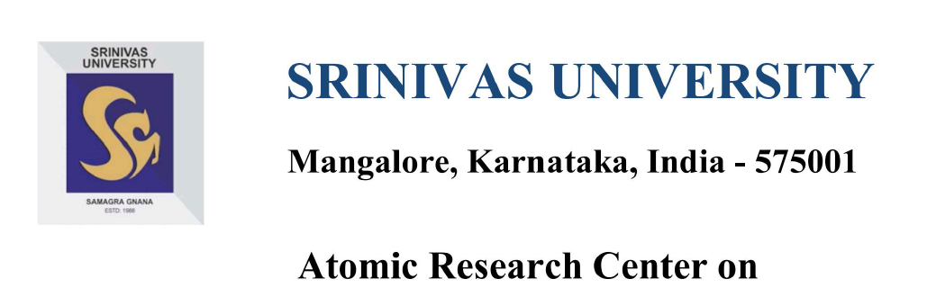
Medical Image Processing using Convolutional Neural Network
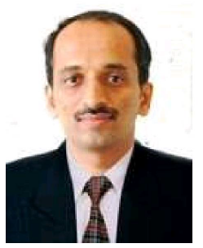  Prof. Subrahmanya Bhat B.  Research Coordinator | 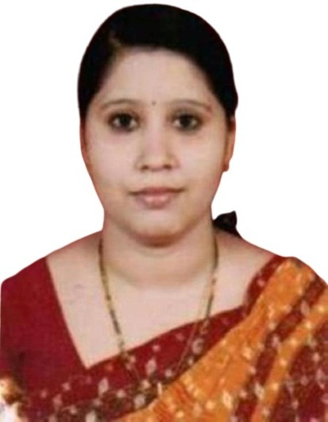  Mrs.Divya Kumari  Research Assistant

Objective:
Convolutional neural networks or CNNs are usually used to analyse visual imagery. This architecture can be used for a number of applications, such as image recognition in self-driving vehicles. Autonomous driving systems use this paradigm to communicate with the car where CNNs collect image input and move it on to a sequence of production decisions (turn right/left, stop/drive, etc.) Then Reinforcement Learning algorithms process these driving decisions. In this project we import custom dataset and experiment with the implementation to achieve the desired performance by increasing the number of epochs, toying with images, adding more layers, etc. using object detection algorithms like SSD, YOLO, Fast R-CNN, etc and constructing a traffic sign classification system for a self-driving car using CNN and the Keras library.

Journal Publications:
- APPLICATION OF ARTIFICIAL INTELLIGENCE TECHNOLOGY IN TESLA- A CASE STUDY” in International Journal of Applied Engineering and Management Letters (IJAEML) at Srinivas Publication.
- “ACCELERATING THE RACE TO AUTONOMOUS CARS – A CASE STUDY” in International Journal of Applied Engineering and Management Letters (IJAEML) at Srinivas Publication.

Conference Publications:
- Production of X-RAYS using X-RAY Tube

Working Papers:
- Brain tumor detection from MRI images using deep learning techniques

Coordinator of the Research Centre:
Research Coordinator:

Prof. Subrahmanya Bhat B
Associate Professor
College of Computer Science and Information Science, Srinivas University,
Mangaluru-575001
Email: sbhat.ccis@srinivasuniversity.edu.in

Research Assistant:

Mrs. Divya Kumari
Research Scholar,
College of Computer Science and Information Science,Srinivas University,
Mangaluru-575001
Email: divyakumari.ccis@srinivasuniversity.edu.in

